***Stock Market Prediction***

**Abstract**

Stock is an unpredictable curve. Prediction in stock market is covered with the complexity and instability. The main aim for the persuasion of the topic is to predict the stability in the future market stocks. Many researchers have performed their research on the movement of future market evolution. Stock consists of fluctuating data which makes data as an integral source of efficiency. Impact on the same chances the efficiency of the prediction. In the recent trend of Stock Market Prediction Technologies machine learning has integrated itself in the picture for deployment and prediction of training sets and data models. Machine Learning employs different predictive models and algorithms to predict and automate things of requirement. The Paper focuses on the use of Regression and LSTM to predict stock values.

1. Regression Based Model

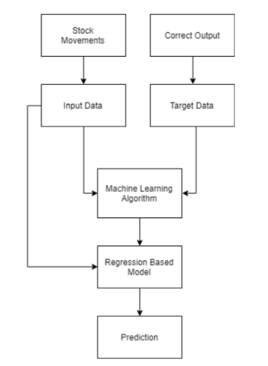

Regression is used for predicting continuous values through some given independent values. The project is based upon the use of linear regression algorithm for predicting correct values by minimizing the error function as given in Figure1. This operation is called gradient descent. Regression uses a given linear function for predicting continuous values:

V = a + bK + error

       

Where, Vis a continuous value; K represents known independent values; and, a, b are coefficients.

1. LSTM Model

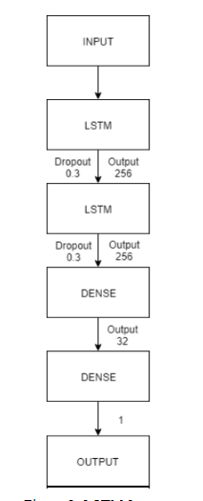

LSTM is the advanced version of Recurrent-Neural- Networks (RNN) where the information belonging to previous state persists. These are different from RNNs

as they involve long term dependencies and RNNs works on finding the relationship between the recent and the current information. This indicates that the interval of information is relatively smaller than that to LSTM. The main purpose behind using this model in stock market prediction is that the predictions depends on large amounts of data and are generally dependent on the long term history of the market. So LSTM regulates error by giving an aid to the RNNs through retaining information for older stages making the

prediction more accurate.

1. Plot between Open price and close price

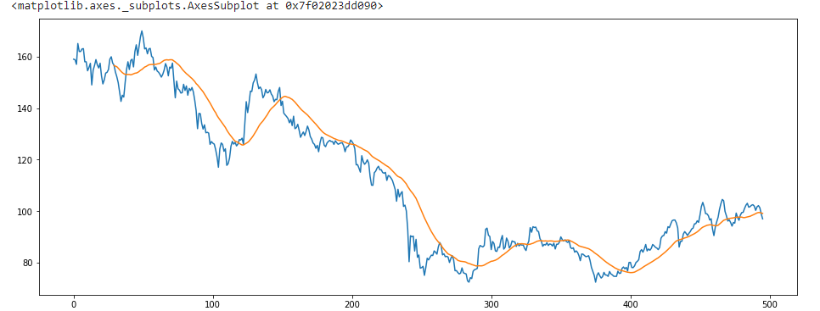

**Conclusion**

Two techniques have been utilized in this paper: LSTM and Regression, on the Yahoo finance dataset. Both the techniques have shown an improvement in the accuracy of predictions, thereby yielding positive results. Use of recently introduced machine learning techniques in the prediction of stocks have yielded promising results and thereby marked the use of them in profitable exchange schemes. It has led to the conclusion that it is possible to predict stock market with more accuracy and efficiency using machine learning techniques.